Final Project Report

TraceFake – AI-Based Image Authenticity Checker



Project Supervisor
Miss Sonia Salman

Submitted By

F25PROJECT3B386

Habib Ur Rehman BC220423776

Software Projects & Research Section,
Department of Computer Sciences,
Virtual University of Pakistan



CERTIFICATE

This is to certify that Habib Ur Rehman (BC220423776) has worked on and completed his Software Project at Software & Research Projects Section, Department of Computer Sciences, Virtual University of Pakistan in partial fulfillment of the requirement for the degree of BS in Computer Sciences under my guidance and supervision.

In our opinion, it is satisfactory and up to the mark and therefore fulfills the requirements of BS in Computer Sciences.

Supervisor / Internal Examiner

Miss Sonia Salman
Supervisor,
Software Projects & Research Section,
Department of Computer Sciences
Virtual University of Pakistan

___________________
(Signature)

External Examiner/Subject Specialist
<<External Supervisor Name>>

___________________
(Signature)

Accepted By:

_____________
(For office use)

EXORDIUM

In the name of Allah, the Compassionate, the Merciful.

Praise be to Allah, Lord of Creation,
The Compassionate, the Merciful,
King of Judgment-day!

You alone we worship, and to You alone we pray for help,
Guide us to the straight path

The path of those who You have favored,

Not of those who have incurred Your wrath,
Nor of those who have gone astray.

DEDICATION

First and foremost, I express my deepest gratitude to Almighty Allah, whose blessings, mercy, and guidance have given me the strength, patience, and determination to complete this important milestone of my academic journey.
I humbly dedicate this work to my parents and family, whose sacrifices, unconditional support, prayers, and continuous encouragement have always motivated me to pursue knowledge and strive for excellence. Their belief in my abilities has been a constant source of confidence throughout my educational journey.
I also dedicate this project to my teachers, mentors, and supervisors whose guidance, knowledge, and valuable feedback have played a significant role in shaping my technical skills, professional mindset, and passion for innovation.
Lastly, I dedicate this project to researchers, educators, digital forensic professionals, and technology innovators working to build trustworthy digital systems and combat misinformation in the modern AI-driven world.

ACKNOWLEDGEMENT

First and foremost, I express my deepest gratitude to Almighty Allah for granting me health, wisdom, patience, and the opportunity to successfully complete this project.
I would like to express my sincere gratitude to my respected supervisor Sonia Salman, whose professional guidance, constructive feedback, technical insights, and continuous encouragement played a vital role throughout the development of this project. Her support helped me improve the quality, direction, and practical implementation of this work.
I am also thankful to the Virtual University of Pakistan, Department of Computer Sciences, for providing an excellent academic environment, valuable learning resources, and practical opportunities that enabled me to develop the knowledge and skills required for completing this project.
I extend my heartfelt appreciation to my teachers, classmates, and friends whose discussions, suggestions, and motivation contributed positively during different phases of this project.
Finally, I am deeply thankful to my parents and family for their prayers, patience, trust, and unwavering support throughout my academic journey. Their encouragement has always been my greatest strength.

PREFACE
The rapid advancement of artificial intelligence has significantly transformed digital content creation. Modern generative models can now produce highly realistic synthetic images that are often difficult to distinguish from authentic photographs. While these advancements offer creative and technological opportunities, they also introduce serious concerns related to digital misinformation, manipulated media, identity misuse, and declining trust in visual content.
This project, TraceFake: AI-Based Image Authenticity Checker, has been developed to address these challenges by providing an intelligent system capable of analyzing digital images and determining whether they are authentic or AI-generated. According to the approved project scope, the system combines deep learning–based image classification with multiple forensic techniques including CNN-based detection, GAN fingerprint analysis, EXIF metadata inspection, and optional Error Level Analysis (ELA).
The primary objective of this project is to develop a reliable and user-friendly image authenticity analysis platform that allows users to upload images, perform forensic analysis, and receive an evidence-based prediction supported by confidence scores and visual forensic cues. The system is designed with scalability, accuracy, usability, and modularity in mind, allowing future integration of advanced detection techniques and improved AI models.
This report presents the complete development journey of TraceFake, covering requirement analysis, system design, architecture planning, dataset selection, implementation, testing, and evaluation. It reflects both academic learning and practical application in the fields of Artificial Intelligence, Digital Forensics, and Deep Learning.

TABLE OF CONTENTS

CHAPTER 1 12
Gathering & Analyzing Info 12
1.1 Introduction 12
1.2 Purpose 13
1.3 Scope 14
1.4 Definitions, Acronyms, and Abbreviations 15
1.5 Project requirements 18
Functional Requirements 18
1. Image Upload / Input 18
2. Image Classification 18
3. EXIF Metadata Analysis 18
4. Error Level Analysis (ELA) 19
5. GAN Fingerprint Analysis 19
6. Reverse Image Search Integration (Optional) 19
Non-Functional Requirements 20
1. Performance 20
2. Accuracy 20
3. Usability 20
4. Reliability 20
5. Scalability 21
6. Maintainability 21
7. Compatibility 21
8. Security 21
9. Availability 21
10. Extensibility 21
1.6 Use cases and usage scenarios 21
1.7 DEVELOPMENT METHODOLOGY 26
VU Process Model: 29
Reasons for selection of VU Process Model: 32
Gantt Chart 34

CHAPTER 2 36
Designing the Project 36
2.1 Introduction 36
2.2 Purpose 36
2.3 Scope 37
2.4 Definitions, Acronyms, and Abbreviations 37
2.5 Architectural Representation (Architecture Diagram) 39
2.6 Dynamic Model: Sequence Diagrams 39
2.7 Object Model/Logical Model: Class Diagram 43
2.8 Dataset 44
2.9 Interface Designs 45

CHAPTER 3 49
Development 49
3.1 Architectural Representation (Architecture Diagram) 49

REFERENCES 50
APPENDIX 51
Appendix A: Model Training Results 51
Appendix B: Usage Instructions 51

CHAPTER 1
Gathering & Analyzing Info

CHAPTER 1

Gathering & Analyzing Info

1.1 Introduction
The rapid growth of Artificial Intelligence has transformed the way digital content is created, processed, and distributed across online platforms. Modern generative models such as OpenAI image-generation systems, Google generative tools, and advanced Generative Adversarial Networks (GANs) are capable of producing highly realistic synthetic images that closely resemble authentic photographs. While these technologies create new opportunities in creativity, media production, and automation, they also introduce serious challenges related to misinformation, digital manipulation, identity misuse, and reduced trust in visual media.
With the increasing availability of AI-generated content on social media, news platforms, online marketplaces, and communication channels, distinguishing between authentic and synthetic images has become a critical challenge. Traditional visual inspection methods are no longer sufficient because modern generated images often contain realistic textures, lighting, facial features, and environmental details that can easily deceive human observers.
To address this challenge, the project TraceFake: AI-Based Image Authenticity Checker has been proposed as an intelligent digital forensic solution capable of analyzing images and determining whether they are real or AI-generated.
The system uses Convolutional Neural Networks (CNN)–based classification models to analyze visual patterns and distinguish real images from synthetic ones. In addition to deep learning classification, the system incorporates forensic techniques such as EXIF metadata inspection, GAN fingerprint analysis, and Error Level Analysis (ELA) to provide supporting evidence for the final prediction.
The system allows users to upload an image in supported formats such as JPEG, PNG, or JPG, after which the image is processed through multiple analysis layers. The final output includes an authenticity prediction (Real or Fake), confidence score, and supporting forensic indicators to help users understand the reasoning behind the system’s decision.
By combining artificial intelligence with digital forensic analysis, TraceFake aims to provide an effective, scalable, and user-friendly solution for image authenticity verification. The system is intended for educational, research, and awareness purposes, helping users better understand the risks associated with synthetic media and strengthening trust in digital content analysis.

1.2 Purpose
The purpose of TraceFake: AI-Based Image Authenticity Checker is to develop an intelligent software system capable of analyzing digital images and determining whether an image is authentic or artificially generated using modern AI technologies. The rapid advancement of image generation models has made it increasingly difficult for users to distinguish real images from synthetic content through visual inspection alone. This creates significant concerns in digital communication, journalism, social media, academic research, business environments, and cybersecurity, where manipulated or AI-generated images may be used to spread misinformation or deceive users.
The primary purpose of this project is to provide a practical and reliable solution that combines Deep Learning–based image classification with digital forensic analysis to improve image authenticity verification. Based on the approved project requirements, the system allows users to upload an image, perform automated analysis, and receive an authenticity prediction supported by confidence scores and forensic evidence.
To achieve this objective, the system integrates multiple analysis techniques. A Convolutional Neural Networks (CNN) model is used for core image classification, while additional forensic modules such as EXIF metadata analysis, GAN fingerprint extraction, and Error Level Analysis (ELA) strengthen the reliability of the final decision.
The project is specifically designed to achieve the following objectives:
- To develop a system capable of classifying uploaded images as Real or AI-Generated (Fake).
- To identify hidden forensic indicators that may reveal synthetic generation or image manipulation.
- To provide confidence-based predictions supported by multiple analytical techniques.
- To offer a simple and user-friendly interface for image upload, analysis, and result visualization.
- To create a modular architecture that allows future integration of improved AI models, forensic algorithms, and additional detection features.
- To support educational research in Digital Forensics, Artificial Intelligence, and image authenticity verification.
In addition, this project aims to build awareness about the growing impact of synthetic media and to demonstrate how intelligent detection systems can help restore trust in digital content. By combining AI-driven classification with forensic evidence, TraceFake provides a meaningful academic and practical contribution toward combating visual misinformation in the modern digital ecosystem.

1.3 Scope
The scope of TraceFake: AI-Based Image Authenticity Checker is to design, develop, and implement an intelligent image analysis system capable of detecting whether a digital image is authentic or artificially generated using modern AI-based image generation techniques. The project primarily focuses on analyzing static digital images and identifying synthetic visual content produced by technologies such as Generative Adversarial Networks (GANs) and diffusion-based image generation models.
According to the approved Software Requirements Specification, the system provides a standalone image authenticity analysis platform where users can upload an image in common formats such as JPEG, PNG, or JPG and receive an automated authenticity assessment. The uploaded image serves as the primary input for multiple layers of analysis including deep learning classification and digital forensic inspection.
The functional scope of the project includes the following major modules:
1. Image Upload and Input Processing
The system allows users to upload digital images through a simple and interactive user interface. Uploaded files are validated for supported file formats and prepared for preprocessing before analysis.
2. AI-Based Image Classification
The system uses Convolutional Neural Networks (CNN) or pretrained deep learning models to classify uploaded images as Real or AI-Generated (Fake) based on learned visual patterns and feature representations.
3. EXIF Metadata Analysis
The system extracts and analyzes embedded metadata from uploaded images, including camera information, software details, timestamps, and editing traces that may indicate synthetic generation or image manipulation.
4. Error Level Analysis (ELA)
The system optionally performs Error Level Analysis to detect compression inconsistencies, tampered regions, or editing artifacts that may support authenticity evaluation.
5. GAN Fingerprint Analysis
The system performs frequency-domain analysis to detect hidden synthetic patterns and generator-specific artifacts commonly left by Generative Adversarial Networks models, providing additional forensic evidence for fake image detection.
6. Result Visualization and Reporting
The system displays the final prediction, confidence score, and supporting forensic cues, enabling users to understand the reasoning behind the authenticity decision.
7. Optional Reverse Image Search
As defined in the approved project scope, the system may optionally integrate external reverse image search services to trace similar images available online.
From the implementation perspective, the system is designed using Python with libraries such as TensorFlow, OpenCV, and Streamlit for model development, image processing, and user interface implementation. Dataset selection and system architecture are further defined in the design document.
Project Limitations
The current scope of TraceFake is limited to static image authenticity detection only. The project does not currently support:
- Real-time video deepfake detection
- Audio manipulation detection
- Live camera stream analysis
- Social media content scraping
- Mobile application deployment
- Cloud-based distributed inference
Despite these limitations, the project establishes a strong foundation for future expansion in AI-driven media forensics and authenticity verification.

1.4 Definitions, Acronyms, and Abbreviations
The following definitions, acronyms, and abbreviations are used throughout the documentation of TraceFake: AI-Based Image Authenticity Checker to provide a clear understanding of technical terms, system components, and technologies used in the project.
General Terms
User:
A person who interacts with the TraceFake system by uploading images, initiating analysis, and viewing authenticity results.
Image Authenticity:
The process of verifying whether a digital image is genuine, naturally captured, or artificially generated/manipulated.
Synthetic Image:
A digitally created image generated using artificial intelligence models instead of being captured through a physical camera.
Digital Forensics:
Digital Forensics
The field of analyzing digital data to identify evidence of manipulation, tampering, or artificial generation.
AI and Machine Learning Terms
AI (Artificial Intelligence):
Artificial Intelligence
A branch of computer science focused on creating systems capable of performing tasks that normally require human intelligence.
ML (Machine Learning):
Machine Learning
A subset of AI that enables systems to learn patterns from data and make predictions without being explicitly programmed.
DL (Deep Learning):
Deep Learning
An advanced machine learning approach that uses multi-layer neural networks for complex pattern recognition.
CNN (Convolutional Neural Network):
Convolutional Neural Networks
A deep learning architecture commonly used for image classification, feature extraction, and computer vision tasks.
GAN (Generative Adversarial Network):
Generative Adversarial Networks
A machine learning framework consisting of generator and discriminator networks used to create highly realistic synthetic images.
Transfer Learning:
Transfer Learning
A machine learning technique where a pretrained model is adapted for a new but related task.
Forensic Analysis Terms
GAN Fingerprint:
A unique hidden pattern or frequency-domain artifact left by GAN-generated images that can help identify synthetic content.
EXIF (Exchangeable Image File Format):
Metadata embedded inside image files containing information such as camera model, date, software, resolution, and editing history.
ELA (Error Level Analysis):
A digital forensic technique used to detect image compression inconsistencies, manipulated regions, or editing artifacts.
Metadata:
Data that provides information about other data. In digital images, metadata may include creation date, device information, editing software, and location information.
Confidence Score:
A numerical value generated by the AI model indicating how confident the system is about its prediction.
System and Software Terms
GUI (Graphical User Interface):
The visual interface through which users interact with the system, upload images, and view results.
Frontend:
The user-facing part of the application responsible for displaying interfaces and receiving user input.
Backend:
The server-side logic responsible for processing images, executing AI models, and generating analysis results.
Preprocessing:
The process of preparing raw images before model analysis, including resizing, normalization, and feature preparation.
Inference:
The process of using a trained AI model to generate predictions on new input data.
Technologies Used in TraceFake
Python:
The primary programming language used for system development, model training, and image analysis.
TensorFlow:
A deep learning framework used for building, training, and deploying neural network models.
Keras:
A high-level deep learning API used for developing neural network models.
OpenCV:
A computer vision library used for image processing, feature extraction, and forensic analysis.
Streamlit:
A Python-based framework used to create the interactive web interface of the system.
Matplotlib:
A visualization library used for plotting graphs, forensic images, and analytical outputs.
These terms establish a common technical foundation for understanding the analysis, design, implementation, and evaluation of the TraceFake system.

1.5 Project requirements

Functional Requirements
Functional requirements describe the specific services, operations, and features that the system must perform to achieve its objectives.:

1. Image Upload / Input
The system shall allow users to upload digital image files in commonly used formats such as JPEG, PNG, and JPG. The uploaded image shall be validated to ensure that the file format is supported and the image is not corrupted before further processing. After successful validation, the image shall be prepared for analysis through preprocessing operations such as resizing and normalization.

2. Image Classification
The system shall analyze the uploaded image using a Convolutional Neural Networks (CNN) model or a pretrained deep learning model to classify the image as either Real or AI-Generated (Fake).
The classification process shall:
- Extract visual features from the uploaded image
- Process the image through the trained deep learning model
- Generate prediction probabilities
- Produce a final classification label
- Calculate a confidence score for the prediction
This requirement represents the primary intelligence module of the TraceFake system.

3. EXIF Metadata Analysis
The system shall optionally extract and analyze EXIF metadata embedded in the uploaded image.
The metadata analysis shall inspect:
- Camera model information
- Device manufacturer
- Image creation date
- Editing software information
- Compression settings
- Resolution and format details
The extracted metadata shall be used as supporting forensic evidence during authenticity evaluation.

4. Error Level Analysis (ELA)
The system shall optionally perform Error Level Analysis (ELA) on uploaded images to identify possible tampered regions or abnormal compression artifacts.
The ELA process shall:
- Recompress the original image
- Compare compression differences
- Highlight suspicious regions
- Generate an ELA visualization
The generated ELA image shall be presented as supporting forensic evidence.

5. GAN Fingerprint Analysis
The system shall perform Generative Adversarial Networks fingerprint analysis to identify hidden synthetic artifacts left by AI image generation models.
The GAN fingerprint module shall:
- Convert the image into frequency-domain representation
- Analyze hidden periodic patterns
- Detect generator-specific artifacts
- Generate forensic indicators for synthetic image detection
This module strengthens the reliability of the final prediction.

6. Reverse Image Search Integration (Optional)
The system may optionally integrate external reverse image search services to identify visually similar images available online.
This module may help users:
- Trace the original source of an image
- Identify previously published versions
- Detect reused or manipulated content
This requirement is considered an optional enhancement feature defined in the project proposal.

Non-Functional Requirements
The noNon-functional requirements define the quality attributes, performance standards, and operational constraints of the TraceFake system.

1. Performance
The system shall process uploaded images efficiently and provide analysis results within an acceptable time frame depending on image size and enabled forensic modules.
The system should maintain responsive performance during:
- Image upload
- Preprocessing
- AI inference
- Forensic analysis
- Result visualization

2. Accuracy
The system shall achieve high prediction accuracy by utilizing properly trained or pretrained deep learning models, carefully selected datasets, and multiple forensic validation techniques.

3. Usability
The system shall provide an intuitive and easy-to-use interface that allows users with minimal technical knowledge to upload images, initiate analysis, and interpret results without specialized training.
The interface shall emphasize:
- Simplicity
- Accessibility
- Clear navigation
- Readable visualization

4. Reliability
The system shall consistently produce stable and repeatable results for identical input images under similar operating conditions.
The system shall include:
- Input validation
- Error handling
- Fault tolerance
- Graceful failure recovery

5. Scalability
The system shall follow a modular architecture that allows future integration of improved AI models, additional forensic techniques, and larger datasets without major redesign.

6. Maintainability
The codebase shall be organized into reusable modules to simplify debugging, enhancement, testing, and long-term maintenance.

7. Compatibility
The system shall operate on standard desktop environments and modern web browsers through its Streamlit-based interface..

8. Security
The system shall safely process uploaded images without unauthorized data access, malicious file execution, or corruption of system resources.

9. Availability
The system shall remain operational whenever required for educational demonstrations, research experiments, and project evaluations.

10. Extensibility
The system architecture shall support future enhancements such as:
- Video deepfake detection
- Mobile deployment
- Cloud inference
- API-based integration
- Real-time media verification
These functional and non-functional requirements provide the technical and operational foundation for the successful implementation of the TraceFake system.

1.6 Use cases and usage scenarios
1.6.1 Use Case Diagram

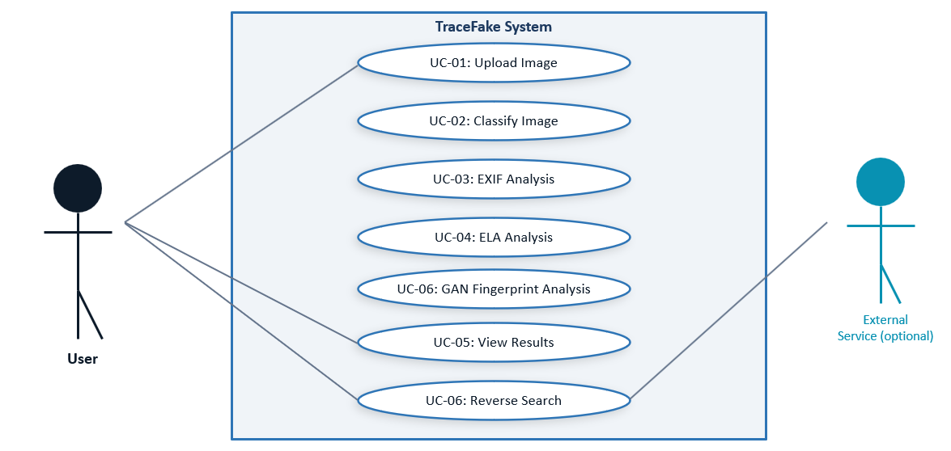

1.6.2 Usage Scenarios

Field | Details
Use Case Title | Upload Image
Use Case ID | UC-01
Actor | User
Description | This use case allows the user to upload an image file to the system for authenticity analysis.
Actions | 1. User selects an image file.2. System validates file format.3. Image is uploaded successfully.
Alternative Paths | If an unsupported file format is selected, the system displays an error message.
Pre-Conditions | User has access to the TraceFake system.
Post-Conditions | Image is successfully uploaded and ready for analysis.
Exceptions | Invalid file type or corrupted image file.
Author | BC220423776

Field | Details
Use Case Title | Classify Image
Use Case ID | UC-02
Actor | System
Description | The system classifies the uploaded image as Real or AI-generated using a CNN or pretrained model.
Actions | 1. System receives uploaded image.2. Image is processed by AI model.3. Classification result is generated.
Alternative Paths | If the model fails to load, classification is halted.
Pre-Conditions | Image has been uploaded successfully.
Post-Conditions | Image classification result is stored for display.
Exceptions | Model loading failure or processing error.
Author | BC220423776

Field | Details
Use Case Title | EXIF Metadata Analysis
Use Case ID | UC-03
Actors | System
Description | The system extracts and analyzes embedded image metadata for forensic evidence.
Alternative Path | A1: If metadata is unavailable, analysis continues without EXIF evidence.
Pre-Condition
  Image is available for analysis.
Action | 1.System reads image metadata.  2. EXIF information is extracted.  3. Metadata is analyzed for suspicious indicators.  4. Results are stored.
Post Condition | EXIF analysis results are available.
Exception | Unsupported metadata format, extraction failure.
Author | BC220423776

Field | Details
Use Case Title | Perform Error Level Analysis
Use Case ID | UC-03
Actor | System
Description | The system applies ELA to detect compression inconsistencies or tampered regions in the image.
Actions | 1. Image is recompressed.2. Error differences are calculated.3. ELA image is generated.
Alternative Paths | If ELA processing fails, the system continues without it.
Pre-Conditions | Image is available for analysis.
Post-Conditions | ELA results are generated and stored.
Exceptions | Unsupported image compression format.
Author | BC220423776

Field | Details
Use Case Title | GAN Fingerprint Analysis
Use Case ID | UC-05
Actors | System
Description | The system analyzes frequency-domain patterns to identify hidden GAN-generated artifacts.
Alternative Path | A1: If frequency extraction fails, the system continues with other analysis modules.
Pre-Condition | Image is available for analysis.
Action | 1. Image is converted to frequency domain.  2. Hidden patterns are extracted.  3. Synthetic artifacts are analyzed.  4. Fingerprint indicators are generated.
Post Condition | GAN fingerprint results are available.
Exception | Processing error, unsupported image structure.
Author | BC220423776

Field | Details
Use Case Title | View Analysis Results
Use Case ID | UC-05
Actor | User
Description | This use case allows the user to view the authenticity result, confidence score, and forensic cues.
Actions | 1. System displays classification result.2. Confidence score is shown.3. Forensic cues are presented.
Alternative Paths | If analysis is incomplete, partial results are displayed.
Pre-Conditions | Image classification has been completed.
Post-Conditions | User reviews the image authenticity results.
Exceptions | Result display failure due to system error.
Author | BC220423776

Field | Details
Use Case Title | Reverse Image Search
Use Case ID | UC-06
Actor | User, Reverse Image Search Service
Description | The system performs a reverse image search using an external service to find similar images online.
Actions | 1. User requests reverse image search.2. System sends image to external service.3. Similar image results are retrieved.
Alternative Paths | If the external service is unavailable, the system notifies the user.
Pre-Conditions | Image analysis results are available.
Post-Conditions | Reverse image search results are displayed.
Exceptions | API failure or network error.
Author | BC220423776

1.7 DEVELOPMENT METHODOLOGY
Methodology is a frame work that is used to structure, plan and control the process of developing an information system. As per requirements we will adopt the methodology named. “VU process model”.

1. VU Process model:
It is the combination of waterfall methodology and spiral methodology. It is likewise called half and half approach of framework advancement.

2. Water Fall Model:
The Waterfall model is a linear, sequential approach to the software development lifecycle that's popular in software engineering and product development. Because of the cascade from one phase to another, this model is known as the waterfall model. This model is depicted in the following diagram.

System Requirements

System and software Design

Implementation and unit testing

Integration and system testing

Operating and Maintenance

Requirement Analysis:
This is the first phase of waterfall model which includes a meeting with the customer to understand his requirements. It is very important to understand the customer requirements and expectations so that the end product meets his specifications. All the requirements related to system to be developed are analyze in this place.
System Design:
System Design helps in specifying hardware and system requirements and also helps in defining overall system architecture.
Implementation and Unit Testing:
First of all, designed the system small units and implemented for testing its functionality.
Integration and system testing:
In this stage, both individual components and the integrated whole are methodically verified to ensure that they are error free and fully meet the requirements. All the units developed in the implementation phase are integrated into a system after testing of each unit. Post integration the entire system is tested for any faults and failures.
Operation and Maintenance:
This is the longest phase of the software lifecycle. The system is installed and put into practical use. Maintenance involves correcting errors which were not discovered in earlier stages of the life-cycle, improving the implementation of system units and enhancing the system’s services as new requirements are discovered.
Spiral Model:
The spiral model is a software development model that uses a series of repeating steps to manage risk and control costs.
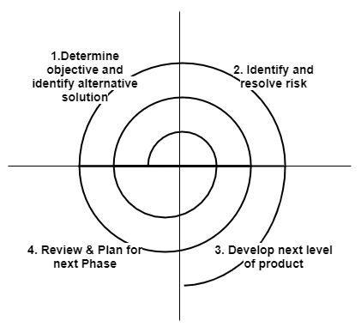
Planning Phase:
This phase involves determining objectives, identifying constraints, and planning the iterations. Risk identification and resource allocation are also part of this phase.
Risk Analysis Phase:
Potential risks are identified, analyzed, and mitigation strategies are developed. Prototyping may also occur during this phase to evaluate uncertainties.
Engineering Phase:
This phase focuses on the development and verification of the product. Design, coding, and testing activities are carried out iteratively.
Evaluation Phase:
Stakeholders review the progress and provide feedback. This phase ensures the system meets user requirements before proceeding to the next iteration.
Chosen Methodology:
We will choose VU process model for our project. A VU Process Model, a hybrid Waterfall and Spiral Model development methodology. The model includes requirements gathering, Planning, analysis, design and development phases.

Requirement Definition
System and Software Design
Implementation and Unit Testing
Integration and System Testing
Operation and Maintenance

- This hybrid approach ensures accuracy and efficiency, as every step is carried out methodically and errors are addressed promptly. The result is a well-structured, error-free project development process.

Our adopted methodology for this project is as follows.

VU Process Model:
VU process model is planned software engineering process by virtual university of Pakistan which is the combination of waterfall model and spiral model in software development.
Basically, a process model explains the simplified description of software processes in iteration to avoid maximum risk. There are many existing methodologies in software engineering processes such as waterfall model, spiral model, building and fix model, rapid prototyping model, incremental model and fountain model etc. These methodologies helps to successful delivery of product, however two methodologies can also be combined like VU process model combines waterfall and spiral model.

The separate introduction of waterfall and spiral model is given below.

Waterfall model:

Waterfall model consist of following heads:

- Requirement:

This head tell about the software requirements as we have by now mentioned our requirements such as functional and non-functional requirements.

- Analysis:

In this step analysis is performed to how one can accomplish the software requirements.

- Design:

In this step the software is designed according to requirements after analysis.

- Coding:

In this the coding of the software is done. We select a programming language for coding such as C++, C # and Java ,php etc.

- Testing:

In this testing phase the software will test whether it is working properly or not.

- Acceptance:

This head performs analysis on the working of software to check that the software is working correctly according to requirement or not. If the software is working properly, it will get acceptance from the user.

The graphical representation of the waterfall model will be as follows
Spiralss Spiral model

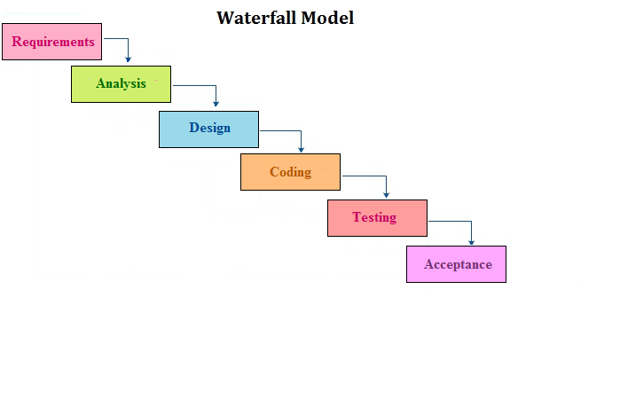

Spiral model:

Spiral model conquers the cons of waterfall model by adding risk analysis to its phase and these phases are iteratively followed by one after another in order to keep away from maximum risk during software development. By Iteratively followed means that task move through four processes many times awaiting quality ensured. In case of any change it is required to iterate the Systemization from all four phases again. That’s why it is called spiral model.
These four processes are as follow:

- Planning:

Planning phase covers scope, requirements and functionality of the system.

- Client Evaluation:

The project that we are delivering should be with quality or else recycle it for further evaluation for its betterment.

- Risk Analysis:

Risk analysis is most important phase of spiral model which defines cost-effective plans in project development. Risk at any stage designates that requirements must be reviewed to discover out solution for the problem by given data in the preceding phase before proceed to the next.

- Development:

Development phase cover up the designing, coding and testing and finally Systemization is transported to client for additional evaluation.

The graphical representation of the Spiral Model will be as follows.

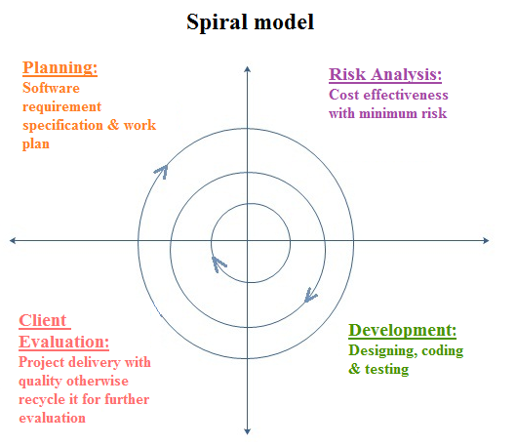

Reasons for selection of VU Process Model:

Following are the basic reasons for choosing VU Process Model for our project.

- Our project is divided into several different phases, each of which must be completed in a sequential manner and submitted to our supervisor for review. This systematic approach ensures that the project progresses in an organized and structured way.
- If any errors or shortcomings are identified during the supervisor's review, they will provide us with feedback and recommend improvements. We will then revise and refine the project accordingly. This iterative process reflects the spiral model's emphasis on continuous refinement and risk management.
- Once a phase is thoroughly completed and receives approval from our supervisor, we will move on to the next phase. This step-by-step progression aligns with the sequential nature of the waterfall model used in the VU process, ensuring that each phase is well-validated before advancing further.
By integrating the characteristics of both the spiral and waterfall models, our VU process model combines iterative refinement with systematic progression.
The graphical representation of Spiral Model will be as follows.

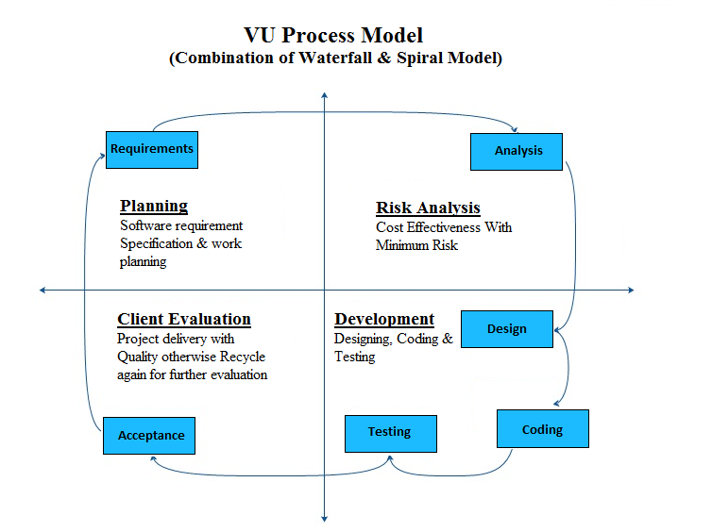

Work Plan
This work plan outlines the development of the , a web based application designed to automate sales processing, inventory tracking, customer management, and reporting for businesses. The system aims to improve efficiency, reduce manual errors, and provide real-time business data.
The project follows the Agile Methodology, with iterative development phases including requirements gathering, system analysis, design, development, testing, and deployment. Technologies used include HTML, Bootstrap CSS, JavaScript, PHP, MySQL, phpMyAdmin, and XAMPP Server.
The development is carried out in modules such as user authentication, product and category management, inventory control, sales processing, invoice generation, and reporting. Each phase includes defined milestones to ensure smooth progress, quality assurance, and successful project completion.

Gantt Chart
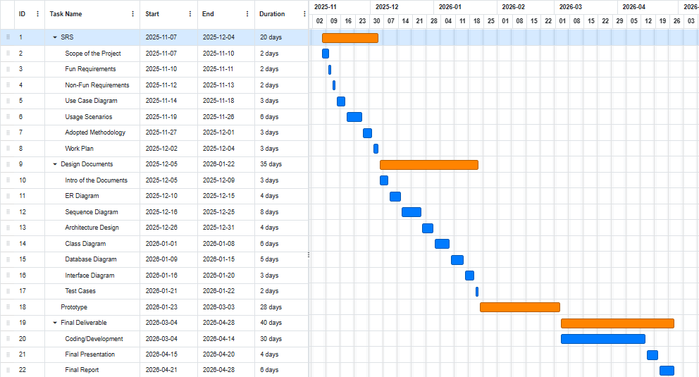

CHAPTER 2
Designing the Project

CHAPTER 2

Designing the Project

2.1 Introduction
The design phase is a pivotal transition in the software development life cycle, moving from the "what" of the requirements to the "how" of the implementation. For the TraceFake project, this chapter serves as the technical blueprint that guides the development of a robust image forensic tool.
The primary focus of this chapter is to translate the functional requirements—such as AI-based classification and forensic analysis—into a concrete system architecture. This involves defining the structural components of the application, the flow of data between different analysis modules (CNN, ELA, and GAN fingerprinting), and the user interface design.
In this phase, we utilize various Unified Modeling Language (UML) diagrams, including Architecture Diagrams, Sequence Diagrams, and Class Diagrams, to visualize the system's logic. By establishing a clear design, we ensure that the final product is not only accurate in its detection capabilities but also scalable, maintainable, and user-friendly. This chapter provides the roadmap for the subsequent development and testing phases, ensuring that every technical decision aligns with the project’s goal of identifying digital misinformation.

2.2 Purpose
The primary purpose of the design phase is to establish a comprehensive technical framework for the TraceFake system. While the previous chapter focused on "what" the system should do, this section defines "how" those requirements will be realized through specific algorithms and architectural components.
The core objectives of this design are:
- Modular Integration: To create a cohesive structure where the CNN Classifier, Error Level Analysis (ELA), and GAN Fingerprint modules function independently yet contribute to a single unified authenticity score.
- Algorithmic Blueprinting: To define the logic for the weighted fusion mechanism, ensuring the trained MobileNetV2 model remains the primary detection engine while secondary forensic signals provide supporting evidence.
- User-Centric Forensic Visualization: To design an interface that does not just provide a binary "Real/Fake" result, but also visualizes complex data (like ELA difference maps and FFT spectrums) in a way that is understandable to the end user.
- Technical Accuracy: To ensure that the system handles various image formats (JPEG, PNG) and metadata (EXIF) correctly, minimizing false positives and providing high reliability in detection.
- Development Roadmap: To provide a clear guide for the implementation phase, reducing logical errors and ensuring that the final software aligns perfectly with the initial SRS (Software Requirements Specification) and student project goals.

2.3 Scope
The scope of the design phase for TraceFake encompasses the technical architecture and logic required to build a fully functional AI-based image authenticity checker. It focuses on the following key areas:
- Detection Pipeline Design: The design includes a multi-layered analysis approach. This involves a Convolutional Neural Network (CNN) based on the MobileNetV2 architecture for deep-learning classification, supplemented by Error Level Analysis (ELA) for detecting pixel-level manipulation and GAN Fingerprint Analysis to identify frequency-domain artifacts.
- Weighted Fusion Logic: A central part of the design scope is the mathematical weighting system (e.g., 70% CNN, 15% ELA, 15% GAN). This ensures the final authenticity verdict is a balanced reflection of all analysis signals.
- Data Handling & Metadata: The scope includes the design of modules to extract and parse EXIF metadata, providing the user with technical details such as camera make, software used, and timestamps, which serve as supporting forensic evidence.
- Front-End Interface: The scope covers the design of a web-based dashboard using Streamlit. This interface will facilitate image uploads and the visual presentation of results, including forensic maps (ELA) and spectral graphs (GAN).
- Performance Constraints: The design aims to provide real-time or near-real-time analysis (within seconds per image) to ensure the tool is practical for regular use.
Exclusions: The scope of this design does not include real-time video deepfake detection or the development of a cloud-based database for user accounts, as the current version is intended to be a standalone desktop-based analysis tool.

2.4 Definitions, Acronyms, and Abbreviations
This section provides a glossary of the technical terms and abbreviations used in the design of the TraceFake system to ensure clarity and consistency.
- CNN (Convolutional Neural Network): A class of deep neural networks, most commonly applied to analyzing visual imagery, used here as the primary classifier.

- ELA (Error Level Analysis): A forensic technique that identifies areas within an image that are at different compression levels. In JPEG images, the entire picture should be at roughly the same level; if a section is at a different level, it likely indicates a digital modification.

- GAN (Generative Adversarial Network): A framework where two neural networks contest with each other to generate new, synthetic data that can pass as real (e.g., Deepfakes).

- EXIF (Exchangeable Image File Format): A standard that specifies the formats for images and sound used by digital cameras and scanners. It contains metadata like camera settings, date, time, and location.

- MobileNetV2: A specific CNN architecture optimized for mobile and edge devices, used in this project for efficient and accurate image classification.

- FFT (Fast Fourier Transform): A mathematical algorithm used to transform an image from the spatial domain into the frequency domain, used here to detect GAN fingerprints.

- Streamlit: An open-source Python library used to create custom web apps for machine learning and data science.

- Weighted Fusion: A method of combining multiple scores (CNN, ELA, GAN) where each score is multiplied by a predefined weight based on its reliability to produce a final verdict.

- Dataset: A collection of related sets of information that is composed of separate elements but can be manipulated as a unit by a computer (e.g., CIFAKE or 140k Real/Fake Faces).

2.5 Architectural Representation (Architecture Diagram)

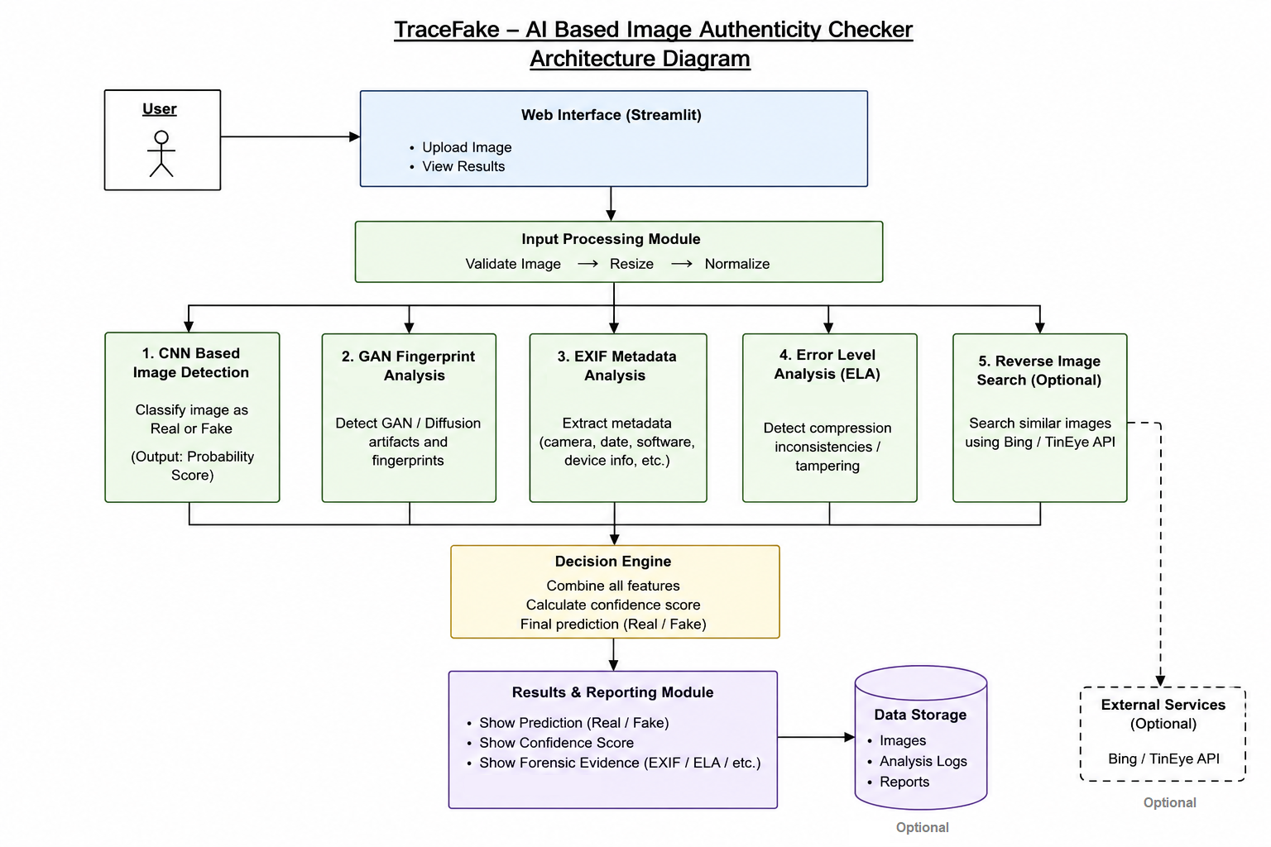

2.6 Dynamic Model: Sequence Diagrams

A Sequence Diagram is a type of UML (Unified Modeling Language) diagram that shows how objects or components interact in a system over time. It represents the sequence of messages exchanged between objects to achieve a specific functionality.
Sequence Diagram – Upload Image
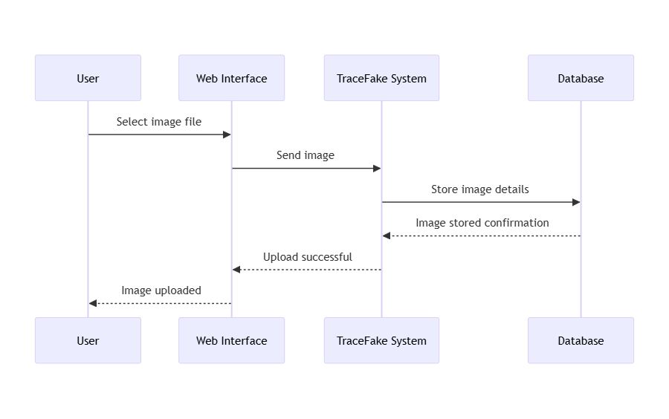

Sequence Diagram – AI Image Detection (Real vs Fake)
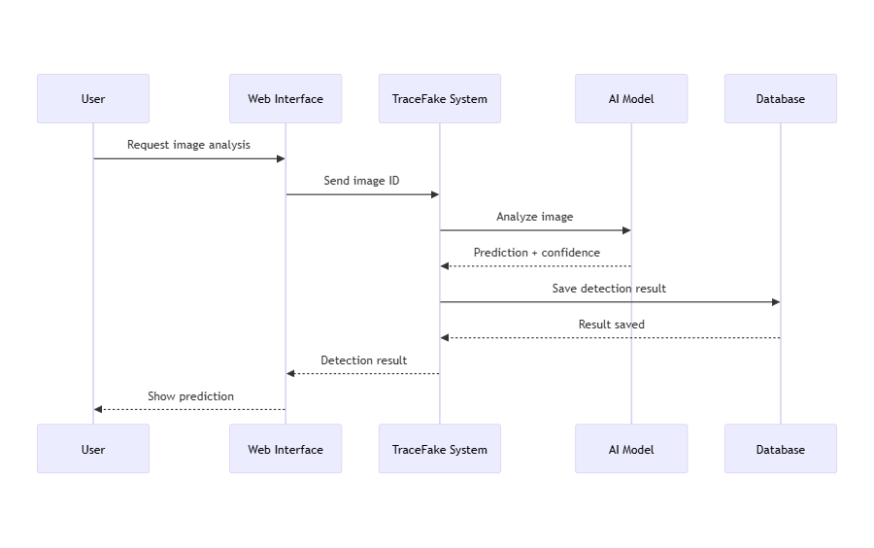

Sequence Diagram – EXIF Metadata Analysis
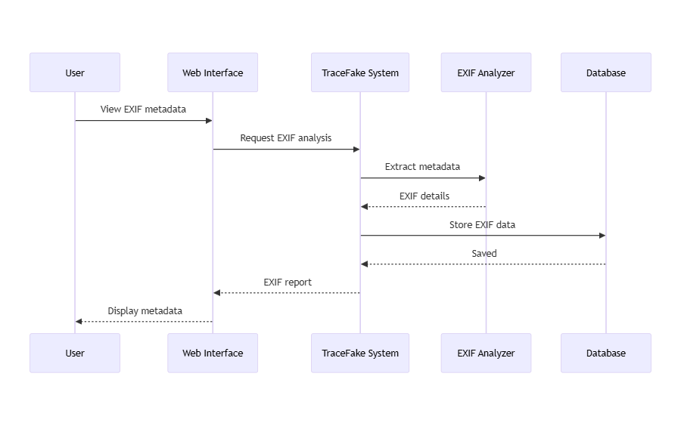

Sequence Diagram – Error Level Analysis (ELA)
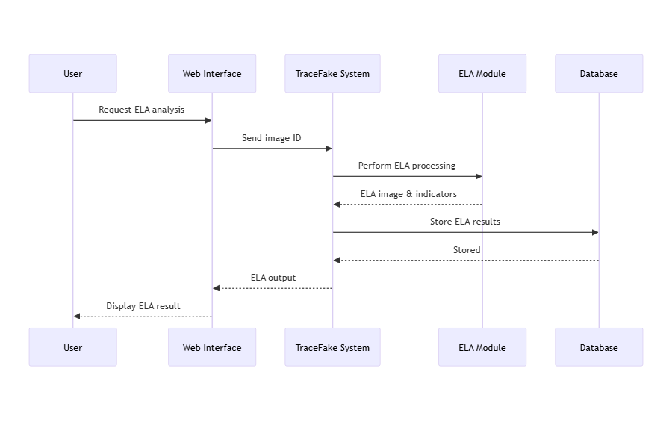

Sequence Diagram – View Final Detection Result
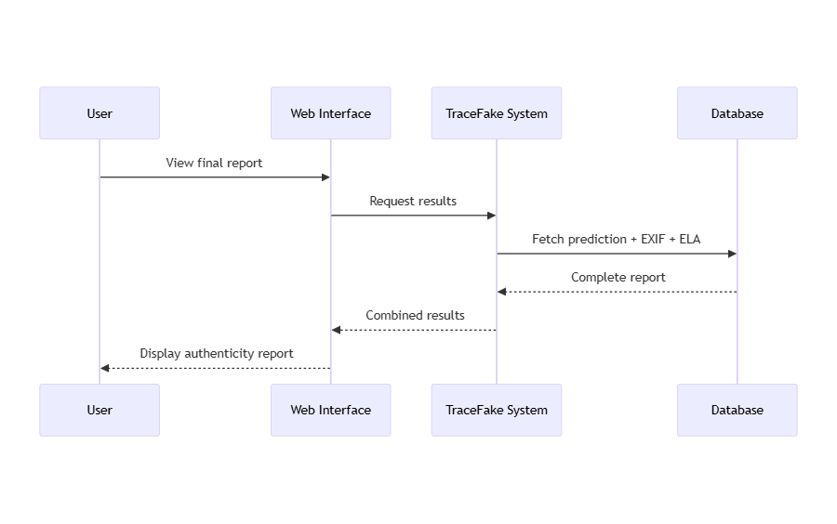

2.7 Object Model/Logical Model: Class Diagram

A Class Diagram is a UML diagram that represents the static structure of a system. It shows the classes, their attributes, methods, and the relationships between them (such as inheritance, association, and aggregation). It is commonly used in object-oriented design.

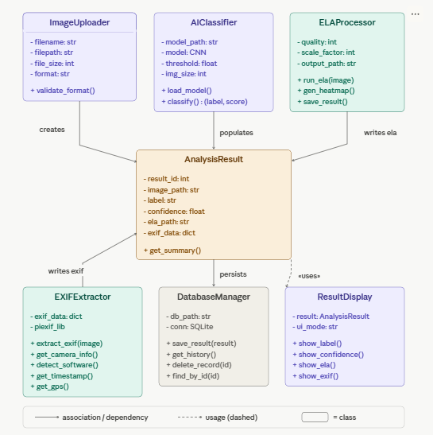

2.8 Dataset
For an AI-based project, the "Data Model" is represented by the structured datasets used for training and the resulting model files. The TraceFake system relies on high-quality, labeled image data to calibrate its detection engines.
2.8.1 Logical Data Structure
The data is organized into three distinct repositories to ensure the model generalizes well to new, unseen images:
- Training Set (70%): Large-scale data used to teach the CNN (MobileNetV2) the difference between authentic skin textures and AI-generated pixel patterns.
- Validation Set (15%): Used during the training process to fine-tune hyperparameters and prevent overfitting.
- Testing Set (15%): A "blind" set of images the model has never seen, used to calculate the final accuracy (97%).
2.8.2 Dataset Entities
The primary data entities utilized in this project are:
- 140k Real and Fake Faces: This is the primary dataset. It contains 70,000 real images from the Flickr-Faces-HQ (FFHQ) dataset and 70,000 fake images generated by StyleGAN.
- CIFAKE Dataset: Used for cross-validation, containing synthetic images to ensure the system can detect fakes from multiple different generative sources.
- Model Weights (.h5): This file acts as the "compiled database" of the project, containing the mathematical parameters (weights and biases) that the system uses to make real-time predictions.

2.9 Interface Designs



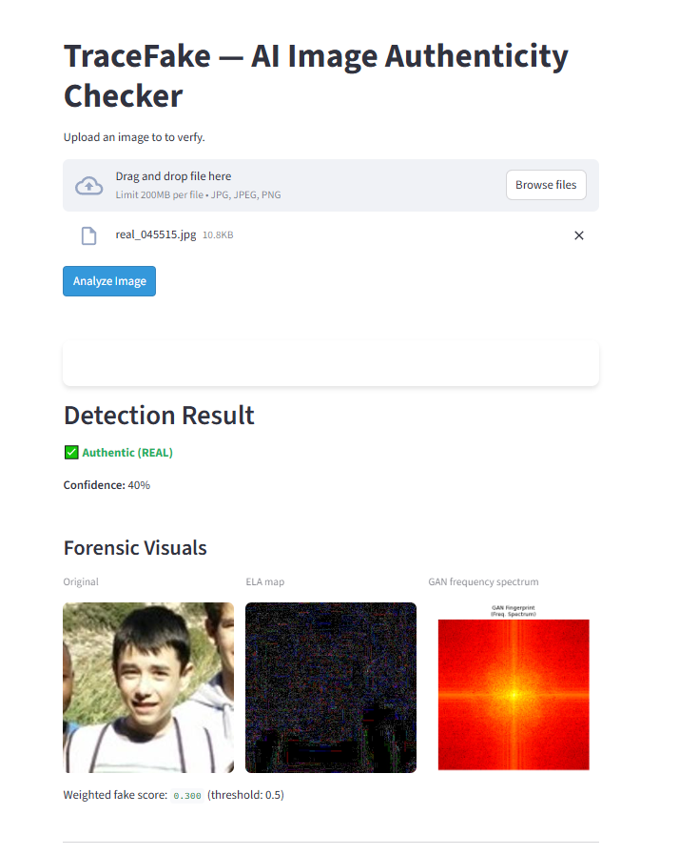

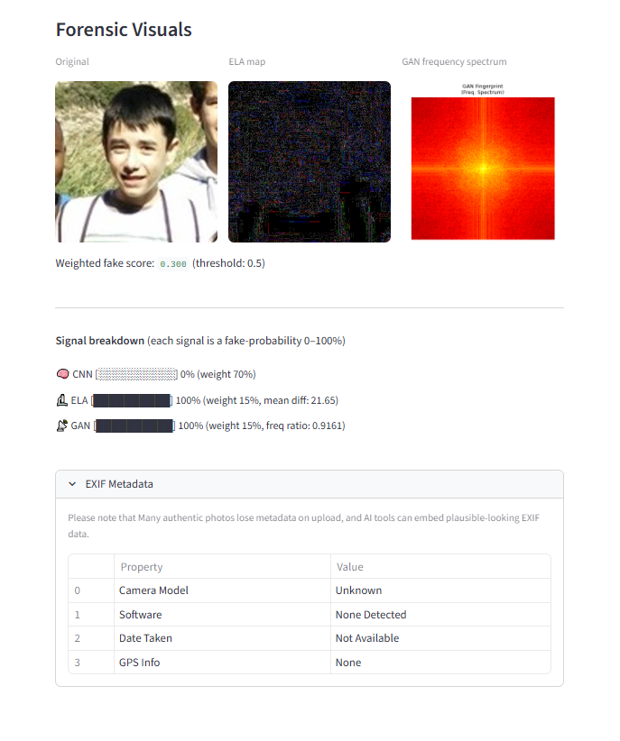

CHAPTER 3
Development

CHAPTER 3

Development

3.1 Architectural Representation (Architecture Diagram)

REFERENCES
Bird, J. J., et al. (2023). CIFAKE: Real and AI-Generated Synthetic Images Dataset. Kaggle. https://www.kaggle.com/datasets/birdy654/cifake-real-and-ai-generated-synthetic-images
Luxonis, H. (2020). 140k Real and Fake Faces Dataset. Kaggle. https://www.kaggle.com/datasets/xhlulu/140k-real-and-fake-faces
Aldiputr. (2022). 140k Real and Fake Faces with ELA. Kaggle. https://www.kaggle.com/datasets/aldiputr/140k-real-and-fake-faces-with-ela
Tan, M., & Le, Q. V. (2019). EfficientNet: Rethinking Model Scaling for Convolutional Neural Networks. ICML 2019. arXiv:1905.11946
He, K., et al. (2016). Deep Residual Learning for Image Recognition. CVPR 2016. arXiv:1512.03385
Goodfellow, I., et al. (2014). Generative Adversarial Networks. arXiv:1406.2661
Krawetz, N. (2007). A Picture's Worth: Digital Image Analysis and Forensics. BlackHat USA 2007.
Virtual University of Pakistan. (2025). CS619 Project Guidelines — Software Projects & Research Section.
TensorFlow Team. (2023). TensorFlow: An Open Source Machine Learning Framework. https://www.tensorflow.org
Python Software Foundation. (2024). Python Language Reference, Version 3.10. https://www.python.org

APPENDIX

Appendix A: Model Training Results

The CNN model (MobileNetV2) was trained on the 140k Real and Fake Faces dataset. The following metrics were achieved during the final epoch:
- Training Accuracy: 98.2%
- Validation Accuracy: 97.4%
- Test Accuracy: 97.1%
- Loss Function: Binary Crossentropy
- Optimizer: Adam (Learning Rate: 0.0001)

Appendix B: Usage Instructions
To run the TraceFake application locally:
- Install requirements: pip install streamlit tensorflow opencv-python pillow scipy exifread.
- Navigate to the project folder in the terminal.
- Execute the command: streamlit run app.py.
- Access the interface via http://localhost:8501 in your web browser.

Thank You!

